# Day 3 — How LLM Works (With Simple Demo)

Today I understood that a Large Language Model (LLM) does not think.
It predicts the next word repeatedly based on probability.
Instead of real intelligence, it performs advanced autocomplete.
Example:
"I drink hot ___"
Possible predictions: tea, coffee
The model selects the most probable word based on learned patterns.

LLM Generation Process
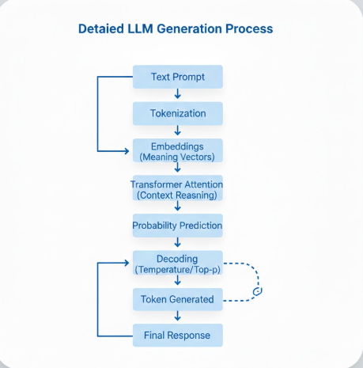

The response is built word by word.

What this demo shows
The Python script simulates how an LLM predicts next words using probabilities.
This is a simplified version of how models like GPT generate text.
Key Learning

LLMs imitate intelligence by predicting language patterns, not by understanding meaning.

